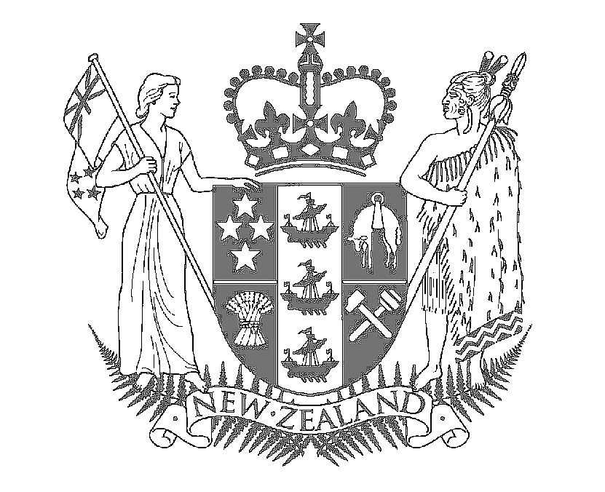

Speech Notes

HON MAHARA OKEROA

SPEECH FOR THE OFFICIAL OPENING 'ATAWHAI' TE REO CLASSROOM

Sacred Heart College,
65 Laings Road, Lower Hutt

Waitangi Day 2007

Tuesday 6th February 2007

Mihi to the Gathered Whanau and Dignitaries

Mihi to the school

E Te Tumuaki, e Lisl, I greet you and the Trustees of this school, for your courage, for your foresight and for your wisdom. You have gifted to the people of this region, the pakake, the rangatahi, the mokopuna, 'Atawhai', a place, within the vision that the Treaty of Waitangi promised.

He Koha aroha tenei

We pay tribute to that gift and we honour it with our presence here today.

By choosing to become educated here whanau add life to the spirit of the Treaty; they become the embodiment of it as they learn to walk with purpose in both worlds, with both languages. And I use purpose advisedly. Bilingualism and biculturalism are not soft politically correct – options! They never have been.

- They are, quite simply, the way of the future.

- They are they way of economic advantage.

- They are the key to opening up the world

The courage you show here is the courage our ancestors had, Maori and Pakeha, when they signed the Treaty. The courage to boldly envision what no other country ever had. The honesty to enact the legal protocols available to them at the time. The wisdom to create real pathways to new futures. Where else was such a Treaty with indigenous peoples signed in 1840?

Anywhere in the world?

This is a day to look back in awe at their legacy: to be as courageous, as honest and as wise as they were in our commitment to living the dream they offered us. To creating the pathways forward that are unique to Aotearoa. The Treaty of Waitangi had given this country the market edge in cultural renaissance – and we are seen as global leaders – with models that interest an increasing number of nations who are intrigued by the buzz that is happening in this country

Last week I ended a trip to Japan in which I met a broad range of Japanese people (including the Emperor, Ministers of the Japanese Government, Business people and Japanese workers) and visited a number of fascinating places (from the Imperial Palace to the largest fish market in the world). During the trip we were involved in a number of high-level meetings and discussions.

Some of the skills and understandings that I used on those trips I learnt at the pa, on the marae and in the kauta – the cookhouse. They were lessons about dealing with people and lessons about mana. How to recognise, manage and negotiate with it. They also taught me that Maori is a culture sensitive to mana in ways that are more similar to the Pacific and to Asia, than to the West.

This is not talk of Aotearoa as a fool's paradise. This country is grappling with significant issues. No one will say otherwise. Including me. But I will not be so crass as to demonise real people, like John Key did, just last week, and then turn them into photo opportunities in the media as he has done this weekend in the Sunday Star Times!

Nation building is deserving of more integrity and moral fibre than that. As are whanau of McGehan Close Keys had maligned who rightly said to his face …we are trying as hard as any other person in this country.

(Pause)

Sadly some New Zealanders are less excited about what this country can offer than the global markets we trade in. That is our challenge, and their opportunity. Our Challenge is to educate the country about the exciting possibilities emanating from the Treaty of Waitangi. Their opportunity is to extend the logo of 'buy New Zealand made' from products like woollen socks to services like education.

Brainpower
Research suggest that one of our organs is barley used beyond 5% of its natural capacity. This may be a dangerous question for a politician to ask but: which organ do you think it is?

Yes I know I am a politician and you may think I am going to say our hearts! You may be right.

But in this example I am referring to our minds.

That’s right. Captain Kirk was wrong: space is not the final frontier – the mind is – the mind is the new frontier of power.

It is staggering to think that we barely use beyond 5% of the mental capacity we have. And stimulating at the same time.

In a past life I spent years as a teacher. In the learning and teaching relationship, where the 5% of our mind power we do use is exercised on a daily basis, lies the greatest advantage we can leverage. It is why education, wherever it occurs, is so important.

Lisl and her teachers have a role – but not alone – as part of the whole whanau that educate a child. All of us – in our roles within our whanau, our communities and the workplace – have a responsibility to be dedicated to investing in ourselves by enhancing the education of those around us.

The bilingual unit provides another strategy to the school, to the teachers and to the whanau, in its mission to enable it to make education a critical tool in opening minds to new ways of seeing the world and engaging with it. Many people stand to have their minds opened up – not just the akonga.

One of the challenges te reo faces is becoming the preferred language of communications, in daily use, in homes and workplaces. 'Atatwhai' is one response to this challenge. I encourage you all to embrace it and make it a living dream you can all enjoy. To the whanau I say: learn along with your tamariki so that they have someone to speak Maori with at home. To the teachers of the school I give the same encouragement, learn alongside the children so that they can approach you with the same confidence that they approach their reo teachers.

Dawn Chorus: Mihi to the Occasion
How fitting it is to be here at this special time. The cool, crisp silence of the morning, a magical time when the new day is ushered in by the 'dawn chorus'. Those magnificent, melodious bird calls that can be quietly savoured before the rush of the day drowns them out.

So beautiful, so unique. So ours.

The dawn chorus is to the bush what te reo rangatira is to the people. Our voice – our contribution to the world family of languages. A unique indigenous language, of a small island country: a taonga, to be treasured. Spoken by increasing numbers but poised still in something of a precarious state.

This school is creating a pathway that will contribute to the revitalisation of te reo Maori and to the tikanga that are embodied within it and expressed through it.

That contribution creates a platform for education to be inclusive, and for the economic, social and political futures that will lead from it to be so enriched

